Course: CSN405 – Network Programming
LAB 3 – Socket Programming

Student name | Phan Ngọc Hạnh Nhi
Student ID | 2131209002

Question 1: Install the Python programs TCPClient and UDPClient on one host and TCPServer and UDPServer on another host.
- Suppose you run TCPServer and you try to connect using UDPClient. What happens? Why?
- They cannot connect. TCP requires a 3-way handshake to establish a reliable connection before sending data. UDP is connectionless and just sends datagrams. The TCPServer will ignore the UDP packets, and the connection will fail.
- Suppose you run UDPClient before you run UDPServer. What happens? Why?
- The UDPClient will send the data successfully (from its perspective) because UDP does not check if the receiver is ready. However, since the UDPServer is not running, the data will be lost. The client might wait indefinitely if it expects a reply (timeout).
- What happens if you hardwire in the python client and server programs different port numbers for the client and server sides in either a TCP or UDP client-server pair?
- The client will send data to a port where no service is listening. The data will never reach the server application, resulting in a "Connection Refused" error for TCP, or dropped packets for UDP.

Question 2: Suppose that in UDPClient.py, after we create the socket, we add the line: clientSocket.bind((’’, 5432))
- Will it become necessary to change UDPServer.py?
- No. The server uses recvfrom(), which automatically extracts the client's IP and port from the incoming packet to send the reply back.
- What are the port num bers for the sockets in UDPClient and UDPServer?
- The UDPClient port is now explicitly 5432. The UDPServer port remains 5001.
- What were they before making this change?
- Before the change, the UDPServer was 5001, but the UDPClient port was an ephemeral port (a random port automatically assigned by the Operating System).

Question 3: Write a simple client-server application using both TCP and UDP
Client Implementation
- Read a line of text from the keyboard.
- Send the text to the server.
- Receive the result from the server and display it.
- Allow the user to send multiple sentences (repeat until the user enter “exit”).
Server Implementation
- Receive a line of text from the client.
- Count how many times the letter 'n' appears in the text.
- Send the count back to the client.

Note: remember using try / except / finally
TCP Server:
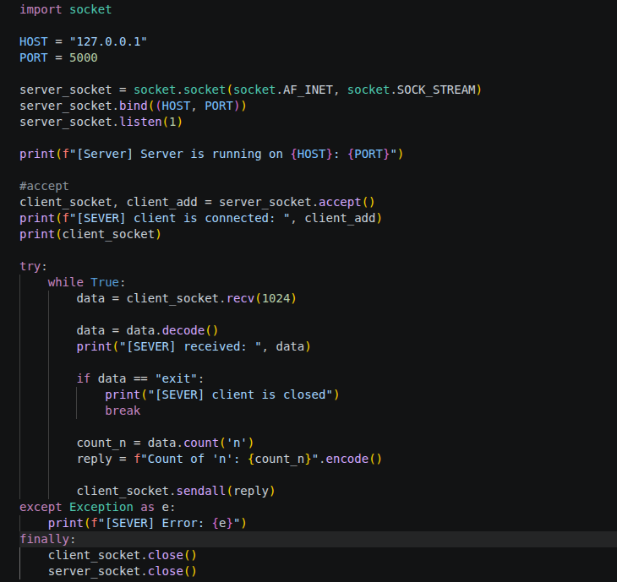
TCP client:
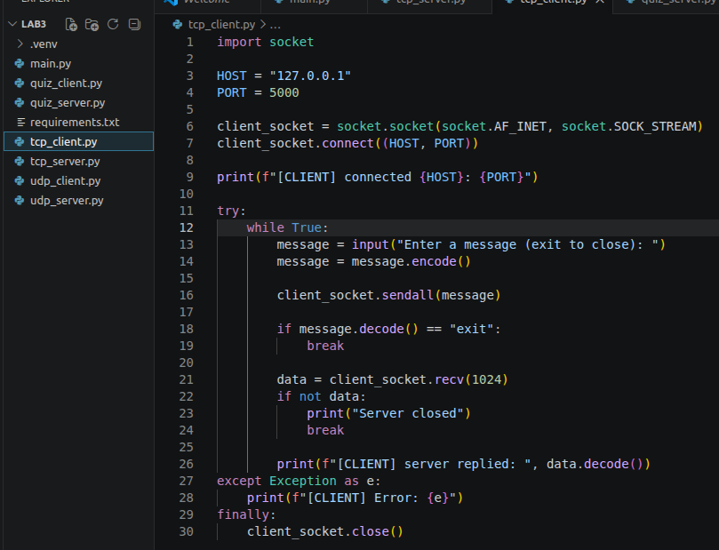
Result:
Tcp_server
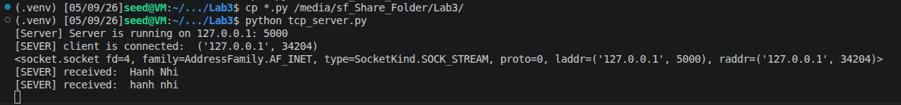
Tcp_client
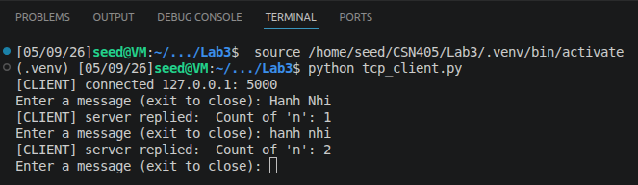

UDP server:
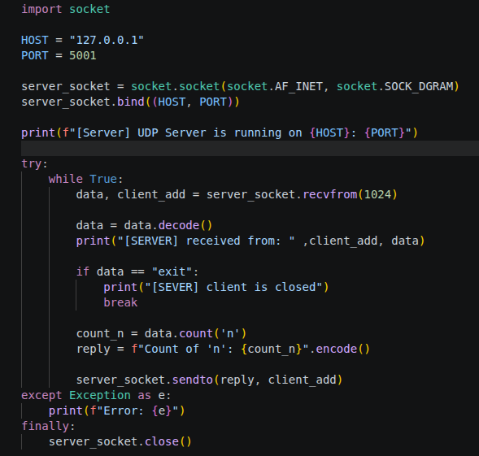

Udp client:
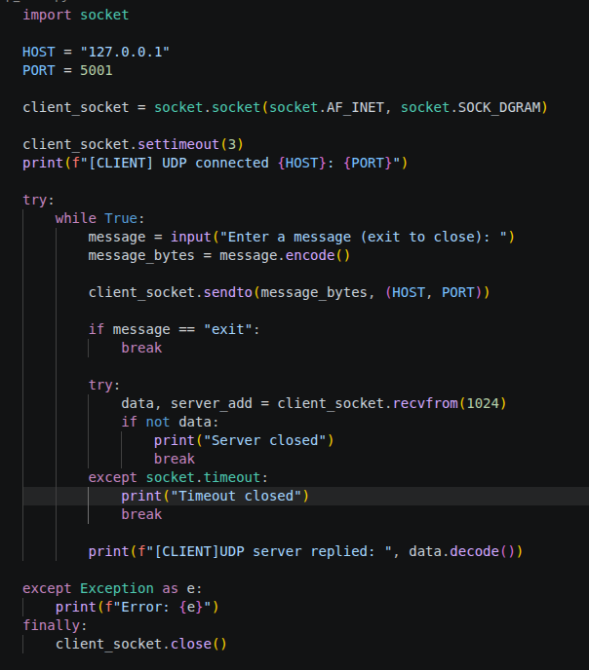

Result:
Udp_server
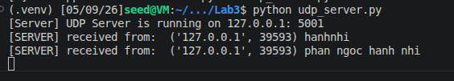
Udp_client
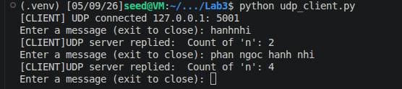

Question 4: TCP True/False Quiz
Server Implementation
Create a TCP server that listens to localhost, port 5050.
Prepare a list of at least 3 True/False questions:
- “Port 443 is used for HTTP.”
- “TCP is a connection-oriented protocol.”
- “UDP guarantees delivery of packets.”
- “The send() method is used to receive data from a socket.”
- “The bind() method is used to connect a client to a server.”

When all questions are answered: send “Quiz finished!” to client
If the client sends quit or exit, the server should close the connection

When a client connects:
- Send the quiz questions to the client one by one
- For each question:
  - Receive the client’s answer (“true” or “false”)
  - Check whether the answer is correct
  - Send one of the following responses:
    - “Yes, it’s correct!” if the answer is correct
    - “No, it’s wrong!” if the answer is incorrect

Client Implementation
- Connect to the server on localhost, port 5050
- Receive each question from the server
- Prompt the user to enter “true” or “false”
- Send the answer to the server
- Display the server’s response
- Continue until all questions are finished or the user enters “quit” or “exit”

Quiz_server
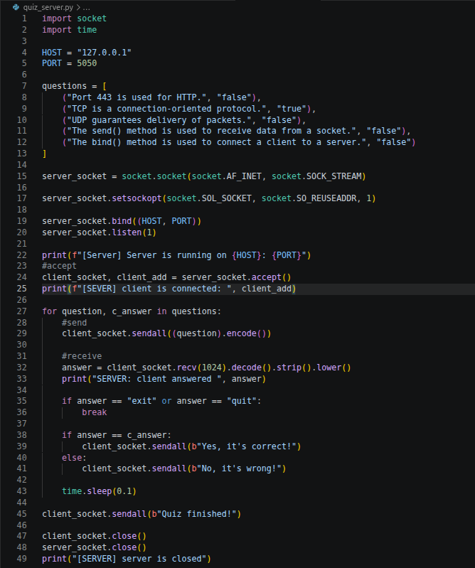

Quiz_client
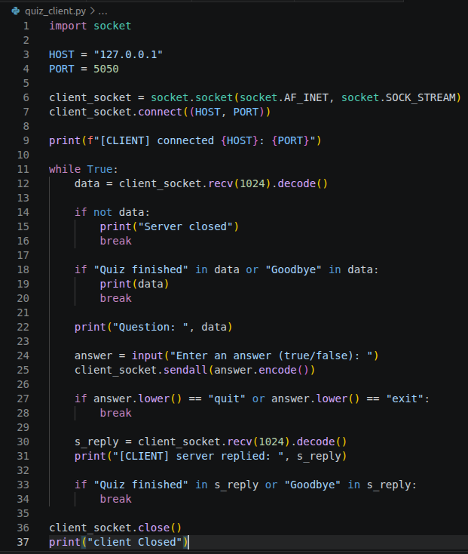

Result
